%% Linear Algebra: G.Strang, ” Differential Equations and Linear Algebra”, Wellesley- Cambridge Press,2014.

Chapter 4 to Chapter 8

1. Linear Equations and Inverse matrices
2. Vector Spaces and Sub Spaces
   1. The column space of a matrix
   2. The null space of A: Solving $Av=0$
   3. The Complete Solution to $Av=b$
   4. Independent, Basis, and Dimension
   5. The Four Fundamental Subspaces / 5.6 Graphs and Network
3. Eigenvalues and Eigenvectors
4. Applied mathematics and ATA
5. Fourier and Laplace Transforms

%% Problems due next (02/21)

1. Vector Spaces and Sub-Spaces
   1. Introduction to Eigenvalues

* Eigenvalues are the key to a system of $n$ differential equations

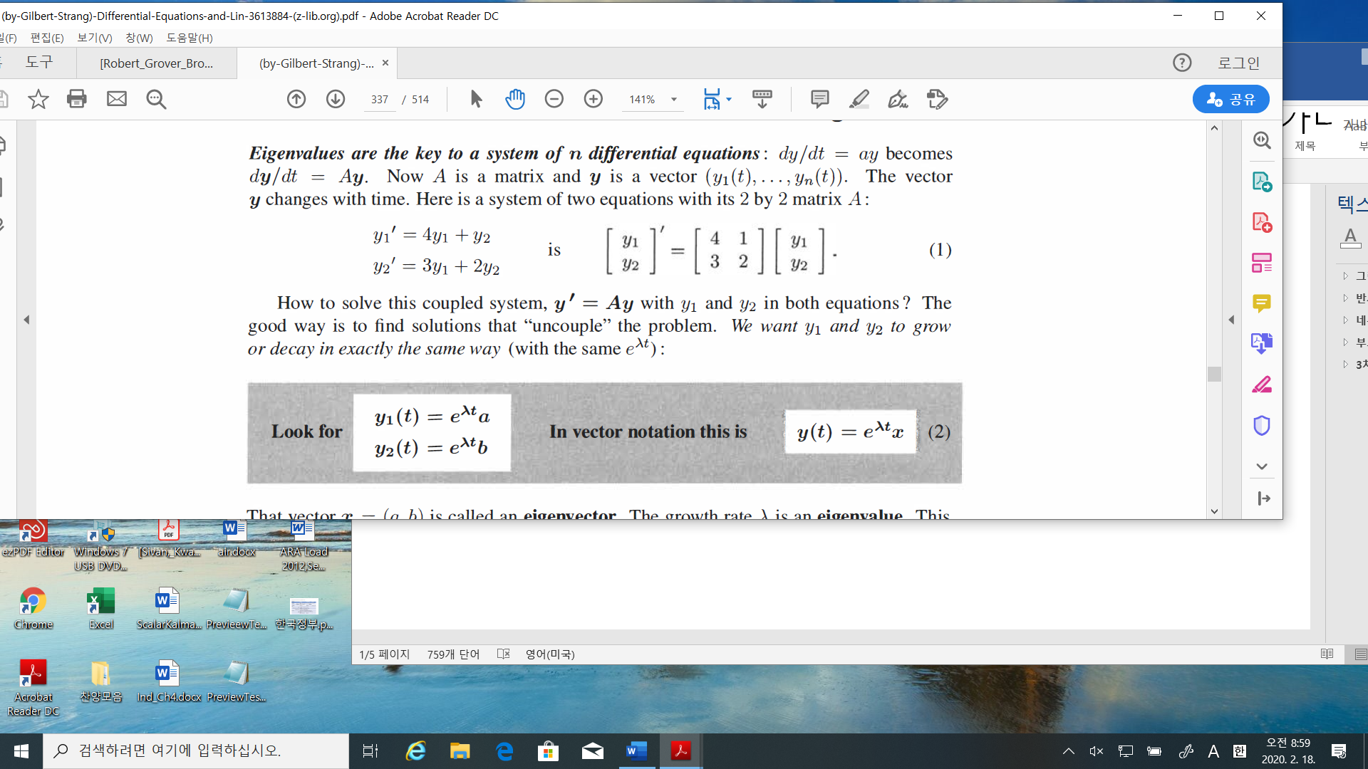

Looking for the solution as

$$y\left(t\right)=e^{λt}x,λ:eigenvalue, x:eigenvector$$

1. Find the e-values and e-vectors

$$λ_{1}=5, x_{1}= \left[\begin{matrix}a \\ b\end{matrix}\right]=\left[\begin{matrix}1 \\ 1\end{matrix}\right]$$

Then

$$y\left(t\right)=e^{5t}\left[\begin{matrix}1 \\ 1\end{matrix}\right]-→ {\left[\begin{matrix}y_{1} \\ y_{2}\end{matrix}\right]}^{'}=\left[\begin{matrix}5e^{5t} \\ 5e^{5t}\end{matrix}\right]=\left[\begin{matrix}4 & 1 \\ 3 & 2\end{matrix}\right]\left[\begin{matrix}y_{1} \\ y_{2}\end{matrix}\right]-→OK.$$

$$λ_{2}=1, x_{2}= \left[\begin{matrix}1 \\ -3\end{matrix}\right]$$

$$y\left(t\right)=e^{t}\left[\begin{matrix}1 \\ -3\end{matrix}\right]-→ {\left[\begin{matrix}y_{1} \\ y_{2}\end{matrix}\right]}^{'}=\left[\begin{matrix}e^{t} \\ -3e^{t}\end{matrix}\right]=\left[\begin{matrix}4 & 1 \\ 3 & 2\end{matrix}\right]\left[\begin{matrix}y_{1} \\ y_{2}\end{matrix}\right]-→OK.$$

1. 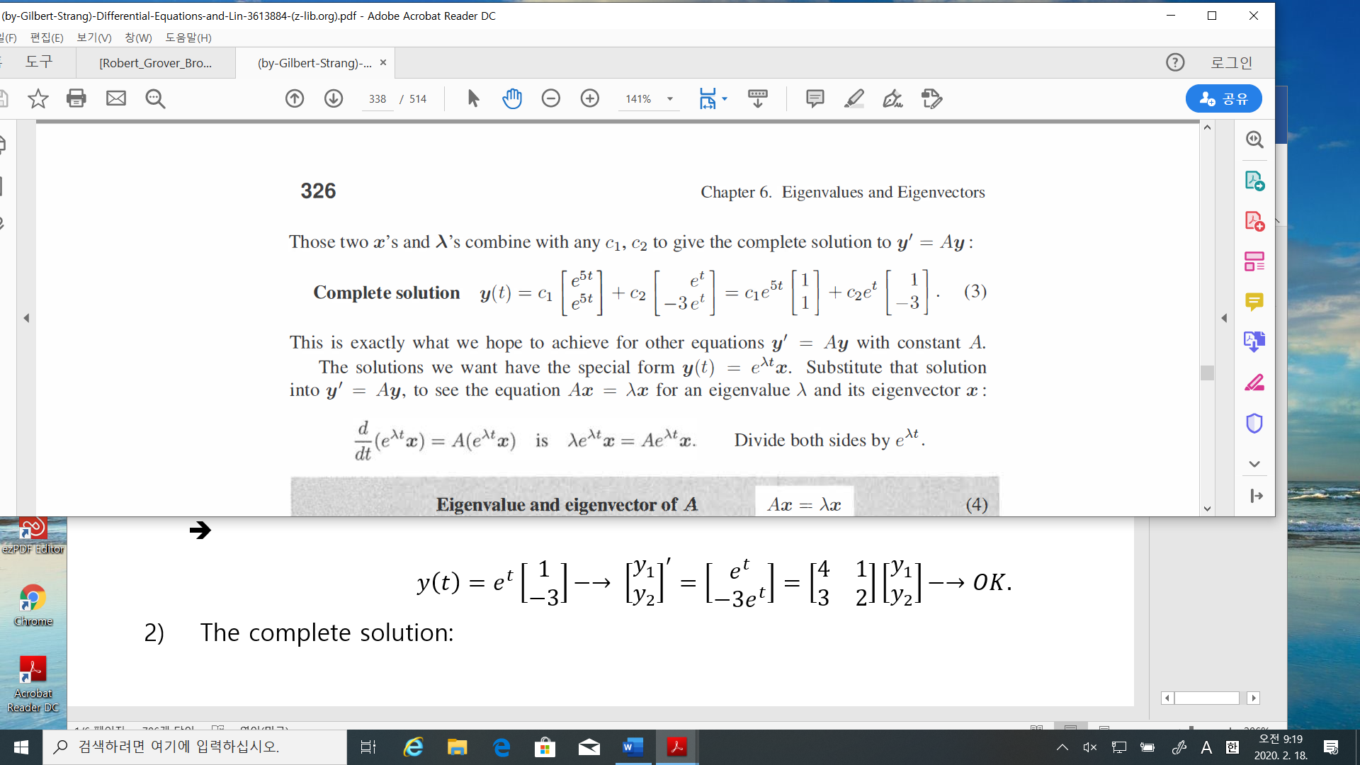 The complete solution:
2. 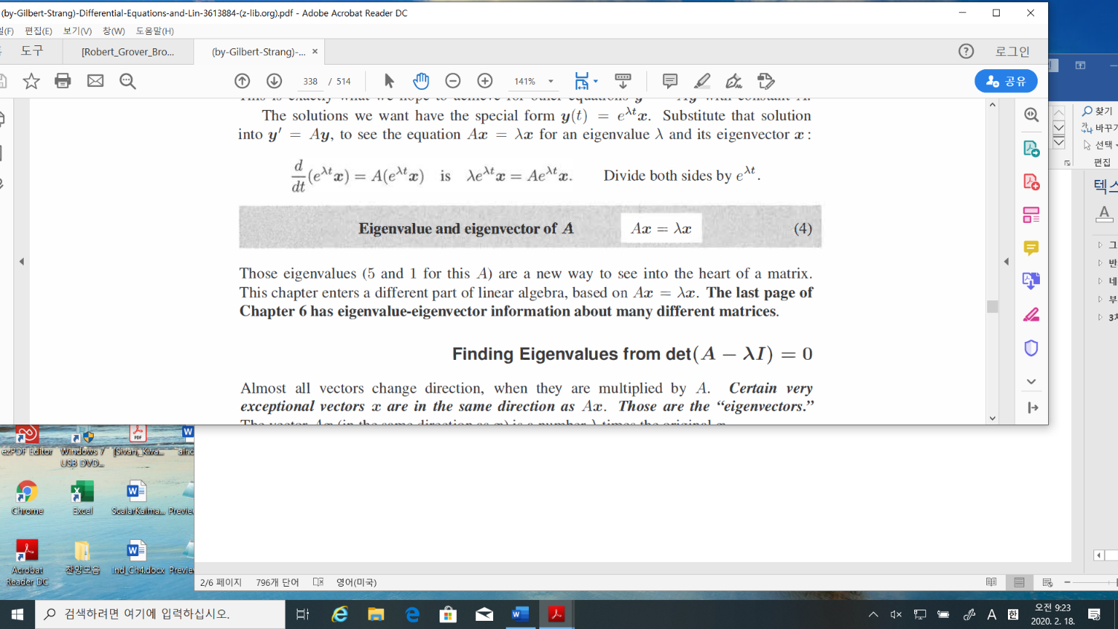Why does this happen?

* Finding the e-values and e-vectors. Let $A= \left[\begin{matrix}a & b \\ c & d\end{matrix}\right]$
$$Ax =λx-→\left(A-λI\right)x=0$$

* For $x≠0, A-λI$ is a singular matrix, i.e., the determinant must be zero.
* The determinant of $A-λI=det\left[\begin{matrix}a-λ & b \\ c & d-λ\end{matrix}\right]=\left(a-λ\right)\left(d-λ\right)-bc=0$
* Exam. 1 Let $A= \left[\begin{matrix}4 & 1 \\ 3 & 2\end{matrix}\right]$

1. E-values:

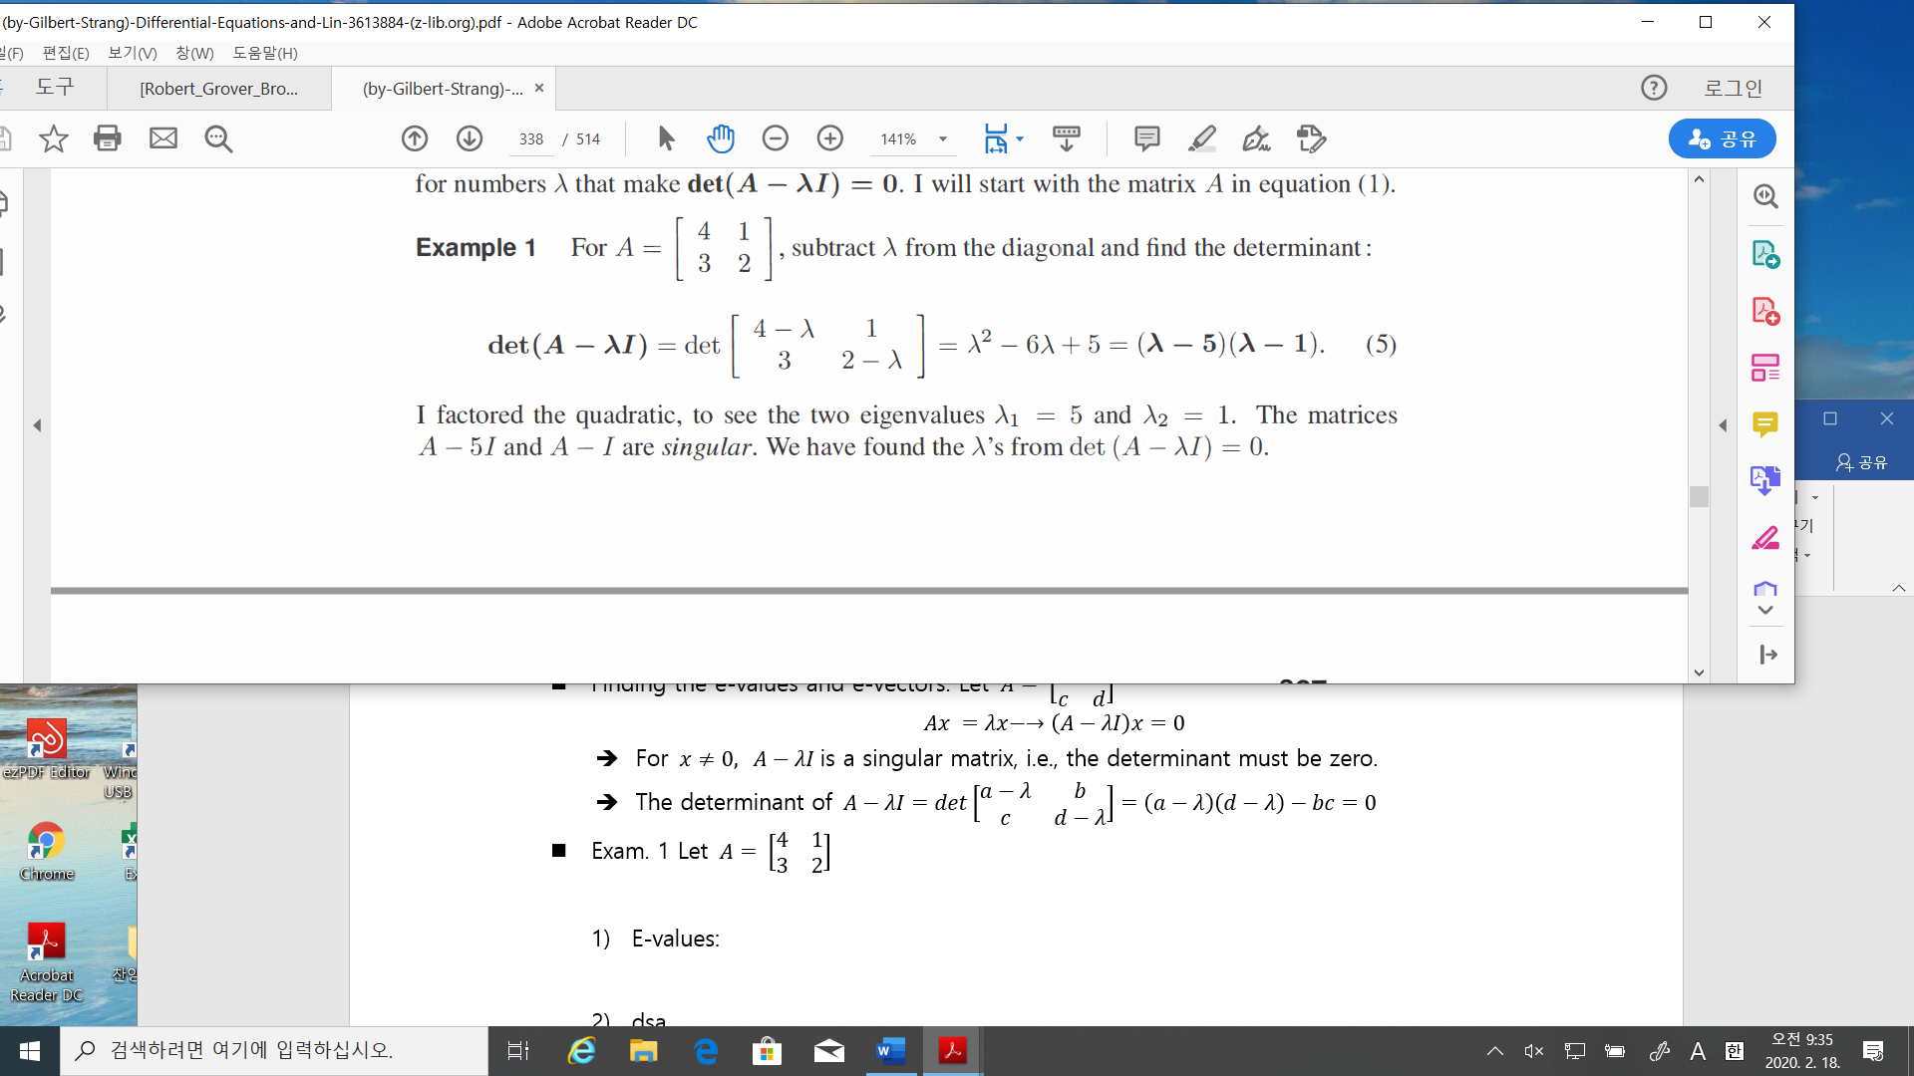

1. E-vectors:

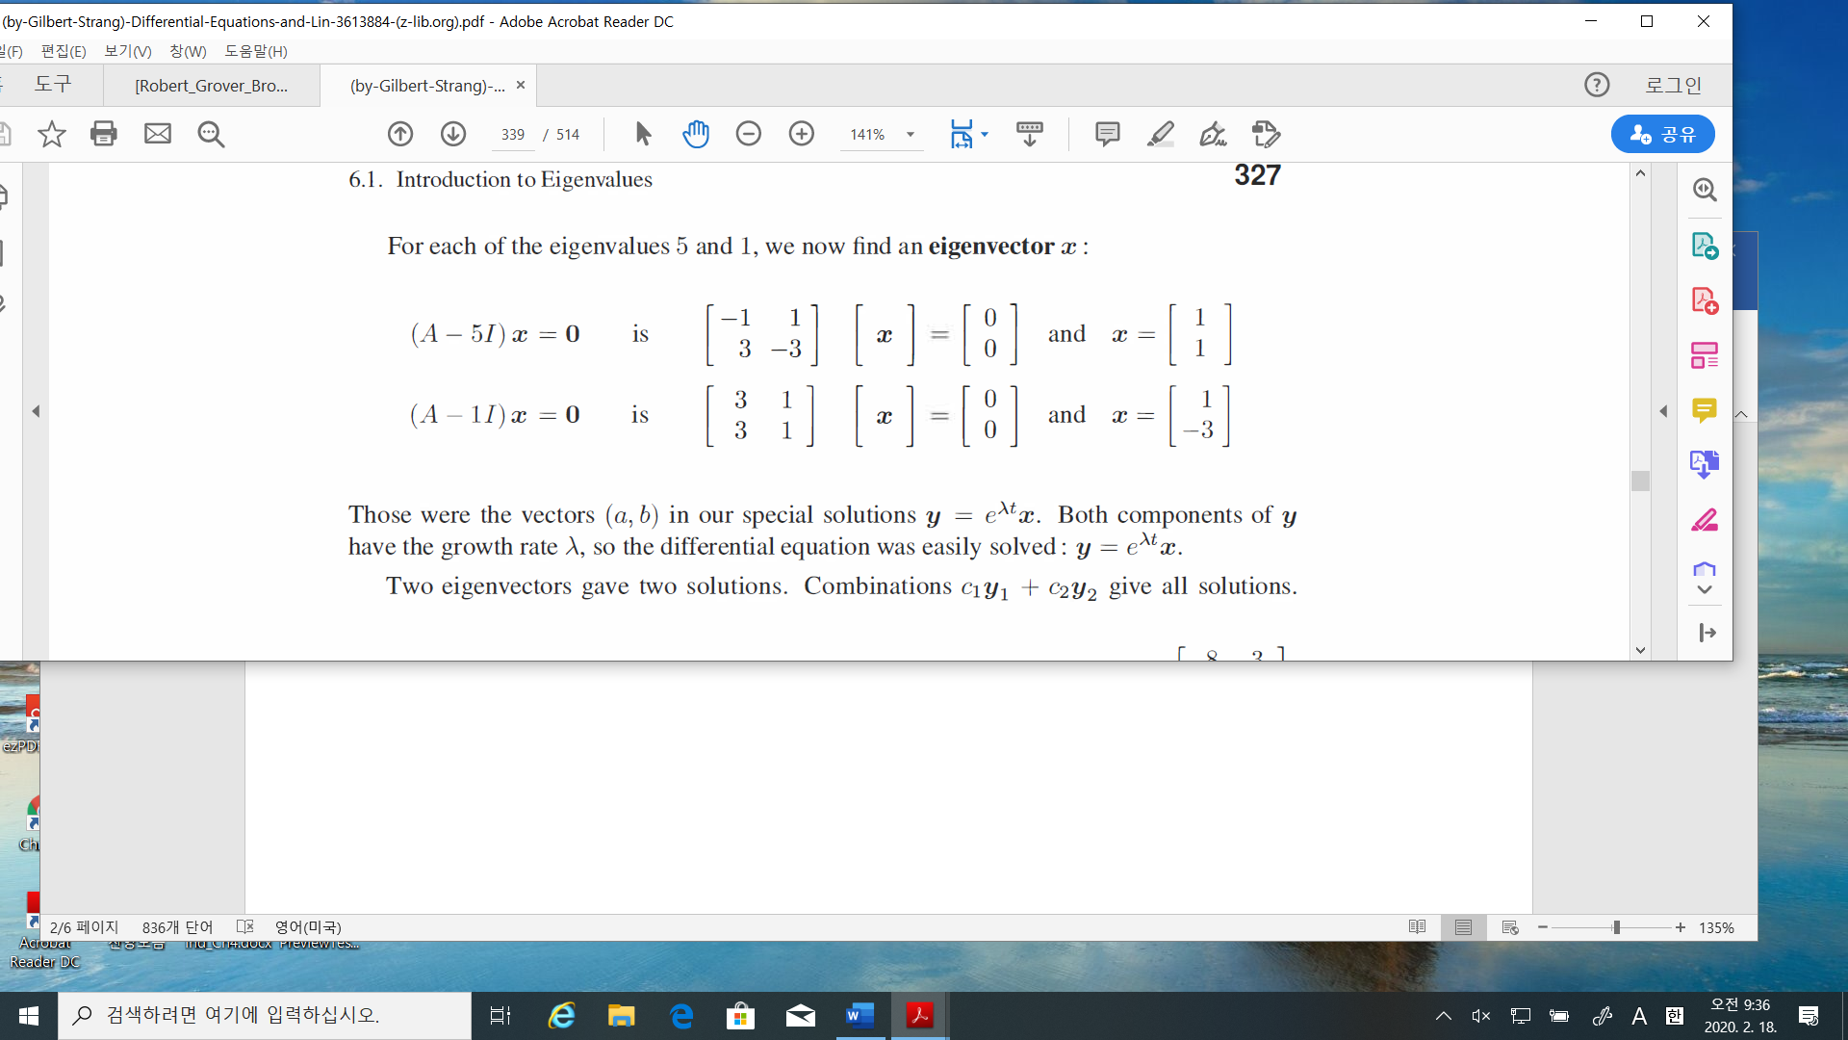

* Powers of matrix: if $Ax=λx,$ then

$$A^{k}x=λ^{k}x$$

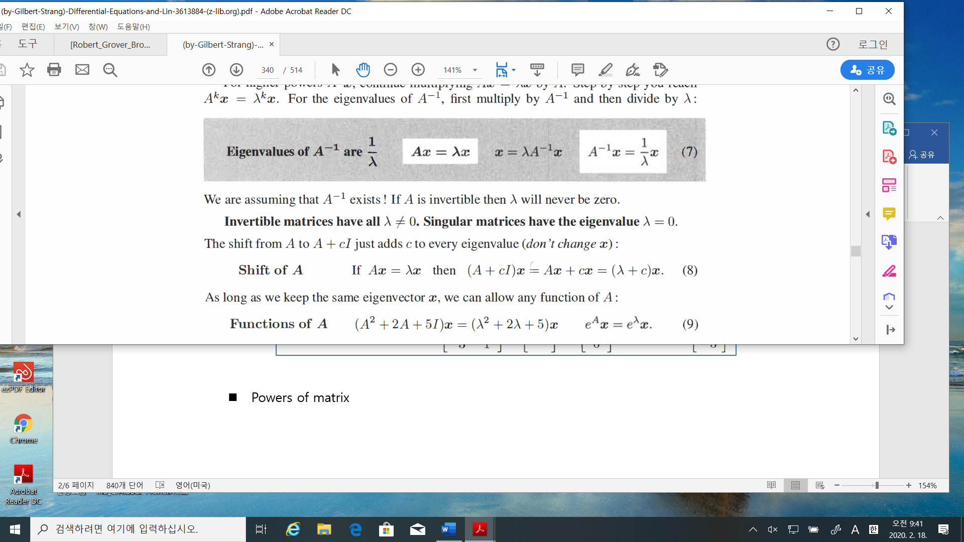

* Facts:

1. Invertible matrices have all $λ≠0.$

Not invertible matrix 🡪 singular matrix

1. Shift of $A$: if $Ax=λx$, then
$$\left(A+cI\right)x =\left(λ+c\right)x$$

2. Functions of $A$: if $Ax=λx$, then
$$\left(A^{2}+2A+5I\right)x=\left(λ^{2}+2λ+5\right)x$$

$$A^{k}x=λ^{k}x$$

$$e^{A}x=e^{λ}x$$

3. E-values of $\left(A+B\right) ≠$ E-values of $A$ + E-values of $B$
4. E-values of $AB$ = E-values of (BA) but not equal to (E-values of (A)) x ((E-values of (A))

* Determinants

1. If $A= \left[\begin{matrix}a & b \\ c & d\end{matrix}\right]$, determinant of $A$ = det($A)$ = $\left(ad-bc\right)$
2. If $A$ is a triangular matrix, then det($A)=product of diagonal entries$

$\det\left(AB\right)=\det\left(A\right)\det\left(B\right)$

$\det{(A)}=det⁡(A^{T})$

* Example 3: $S= \left[\begin{matrix}2 & 1 \\ 1 & 2\end{matrix}\right]$, then E-values of $A=3, 1$ and each e-values has an e-vector as

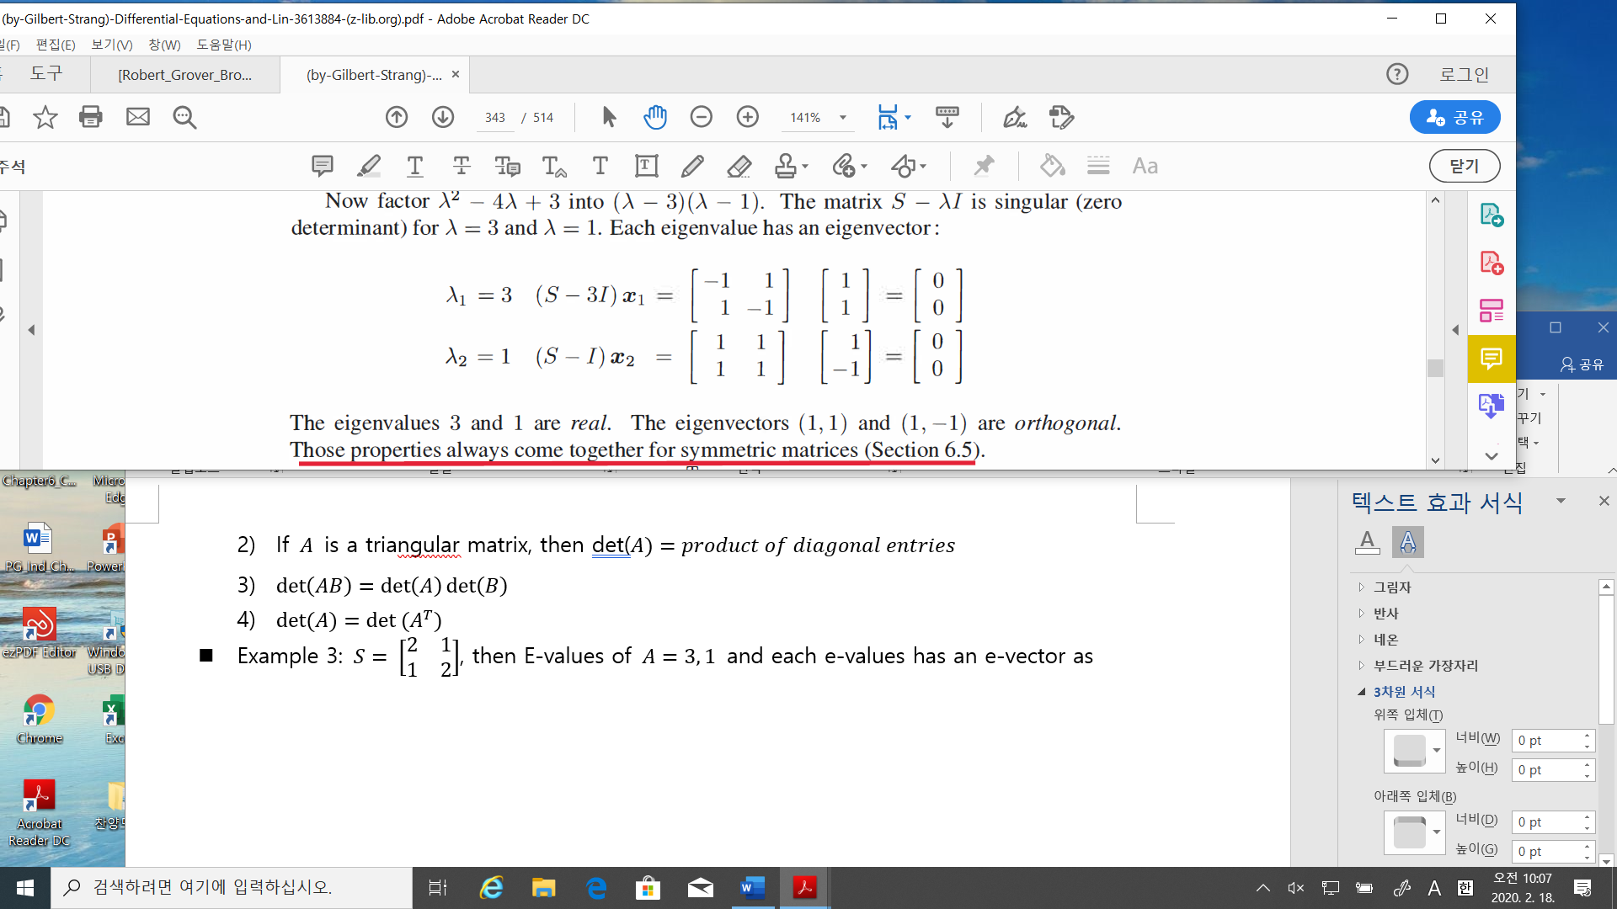

* Example 4: Complex e-values/e-vectors $A= \left[\begin{matrix}0 & -1 \\ 1 & 0\end{matrix}\right]$

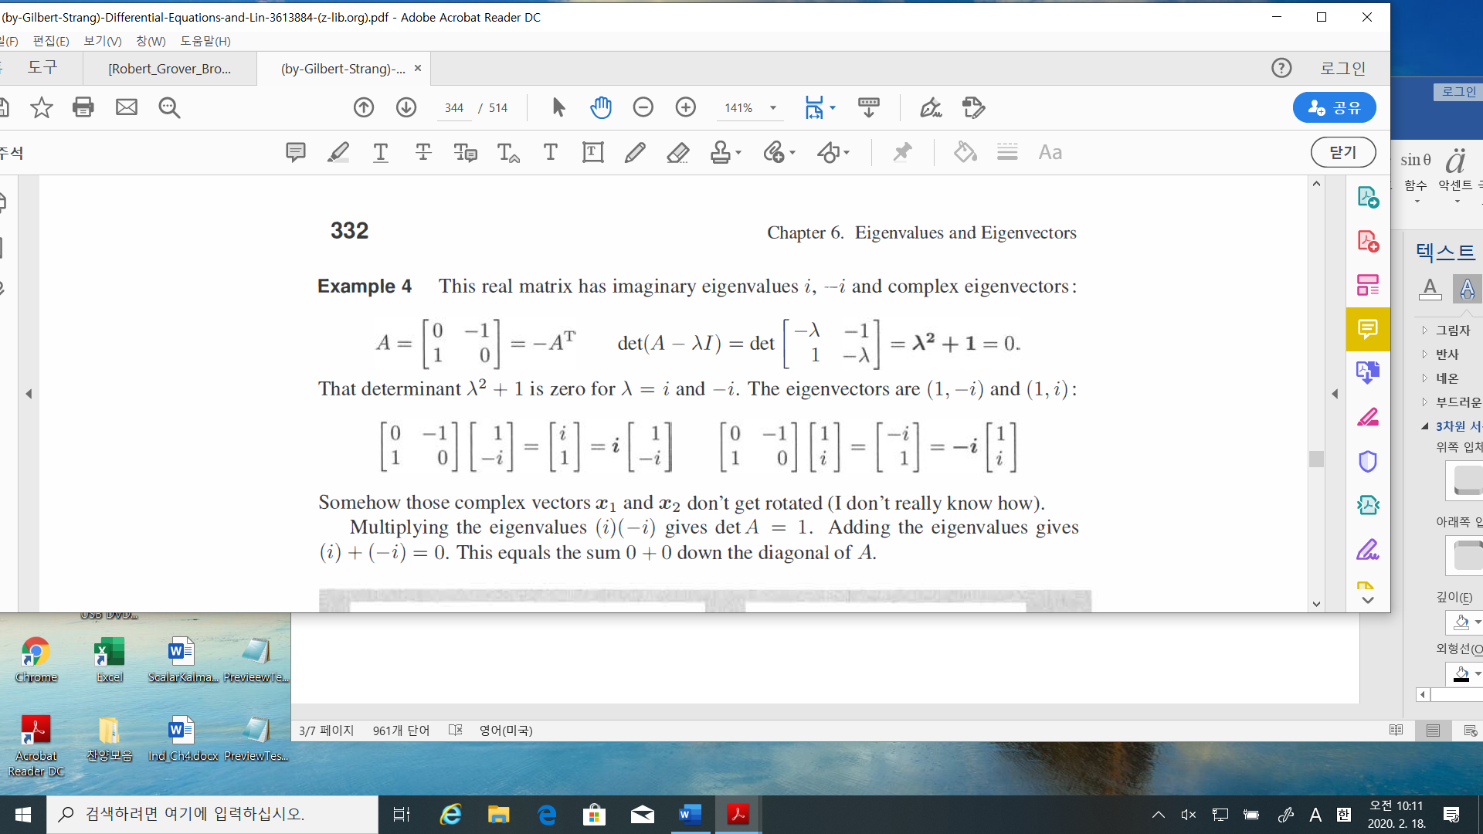

* Problem: find e-values/vectors of $A= \left[\begin{matrix}\cos{θ} & -\sin{θ} \\ \sin{θ} & \cos{θ}\end{matrix}\right]$
  1. Diagonalizing a matrix

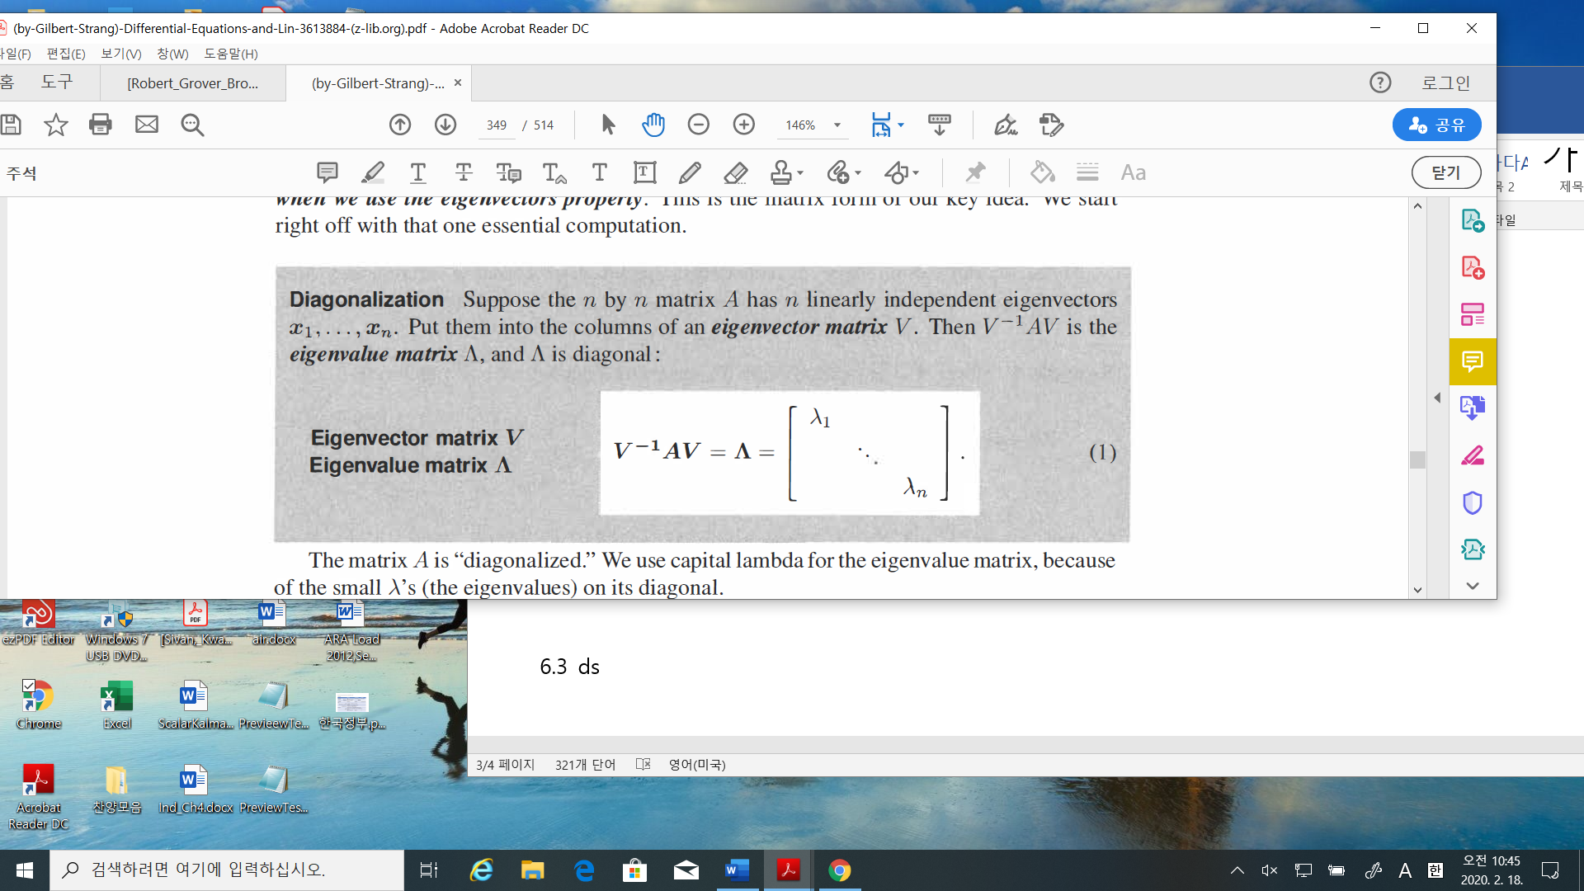

* **The condition of linearly dependent e-vectors are important.**
* Example_1

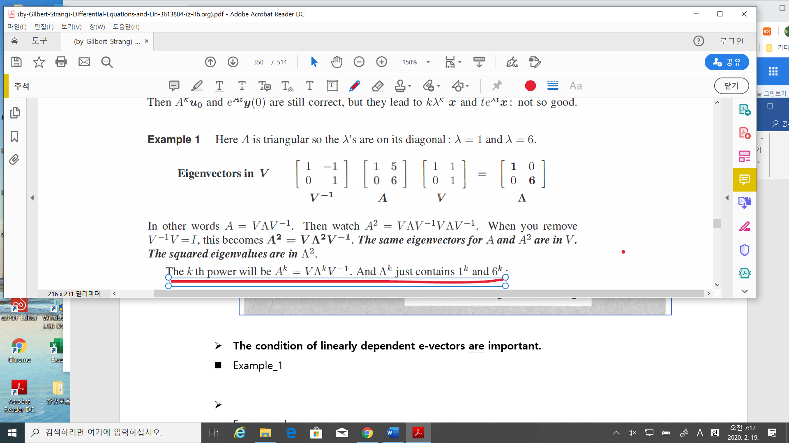

* Facts:

Let $V^{-1}AV =Λ$, then $A=VΛV^{-1}$

$$A^{2}=\left(VΛV^{-1}\right)\left(VΛV^{-1}\right)=VΛ^{2}V^{-1} \\ A^{k}=VΛ^{k}V^{-1} \\ A^{-1}={\left(VΛV^{-1}\right)}^{-1}={\left(V^{-1}\right)}^{-1}Λ^{-1}{\left(V\right)}^{-1}=VΛ^{-1}V^{-1}$$

* Remarks(page 338)

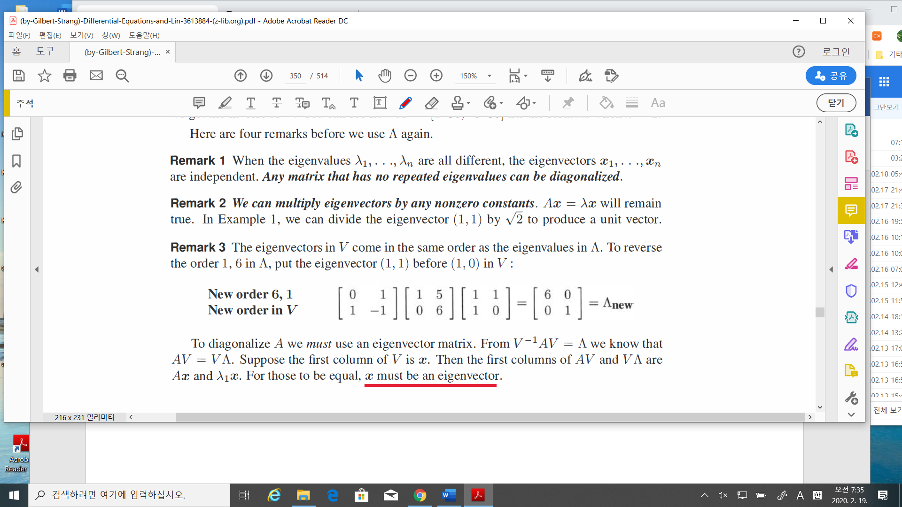

* So if e-values are different, **then e-vectors is a basis**, i.e., for any $x∈R^{n},$

$x=c_{1}x_{1}+c_{2}x_{2}+,…+c_{n}x_{n}$

* 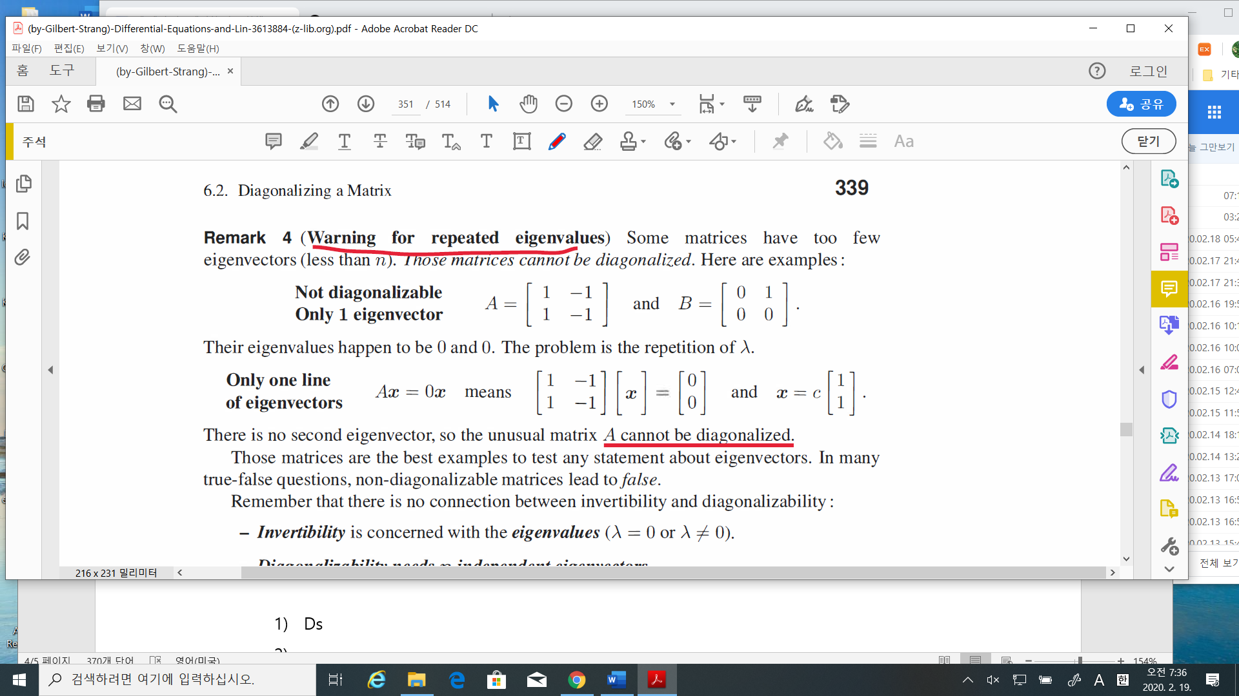Remarks(page 339)
* For example

$$A=\left[\begin{matrix}1 & 1 \\ 0 & 2\end{matrix}\right], B=\left[\begin{matrix}1 & 0 \\ 0 & 1\end{matrix}\right], C=\left[\begin{matrix}1 & 1 \\ 0 & 1\end{matrix}\right]$$

$A$ is diagonalizable, B is already diagonalized(even if the e-values are equivalent)

But $C$ cannot be diagonalizable.

* Remarks.

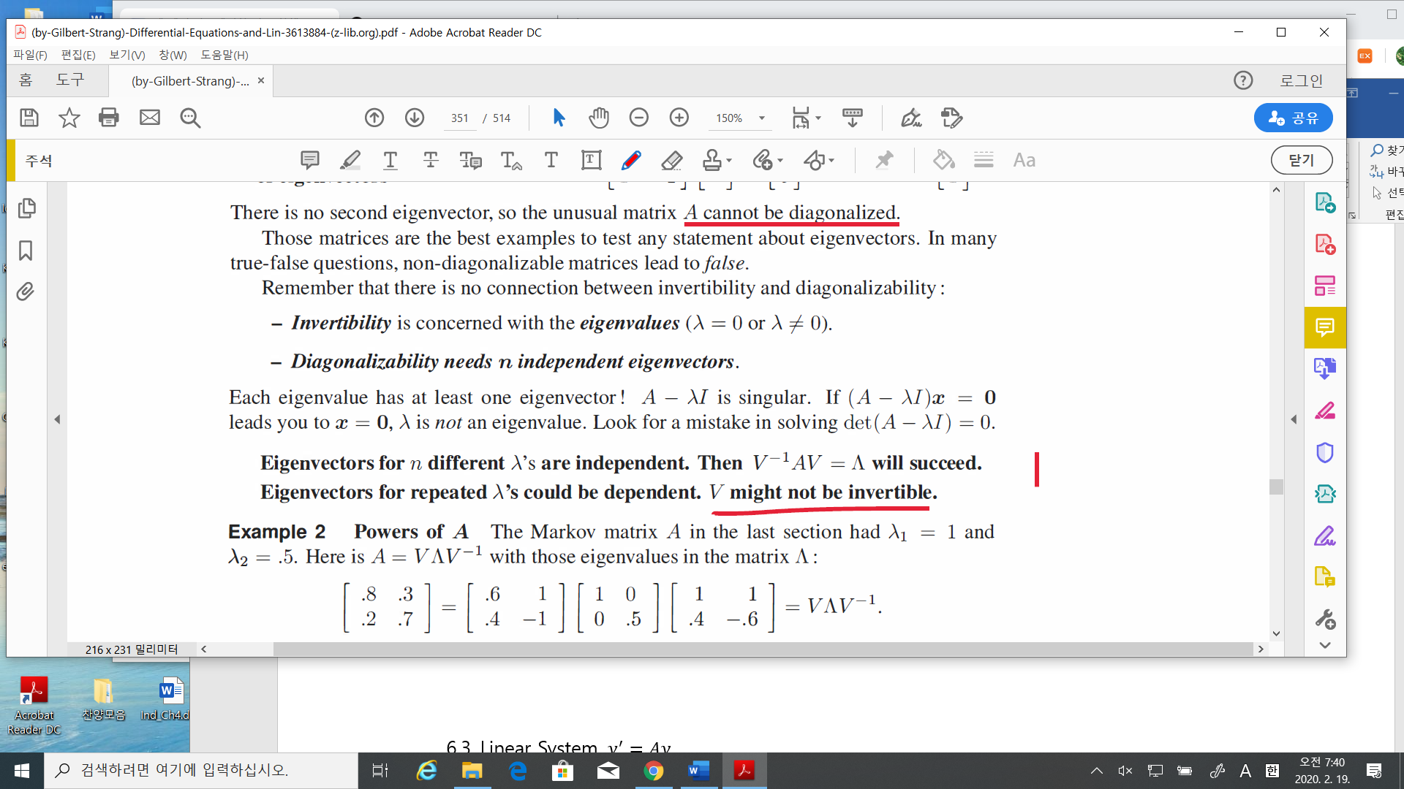

* Let $A_{n×x}$. How many e-values of ? 🡪 if allowed the multiplicity, there are $n$ e-values.

How many e-vectors of 🡪 <= n

* Problem: Find e-values and e-vectors of $B,$ and C
$$B=\left[\begin{matrix}1 & 0 \\ 0 & 1\end{matrix}\right], C=\left[\begin{matrix}1 & 1 \\ 0 & 1\end{matrix}\right]$$

* Matrix Power $A^{k}$

1. Solution to a difference equation

$$u_{k+1}=Au_{k} , u_{0}(initial condition)$$

$u_{k}=Au_{k-1}= A^{2}u_{k-2}=A^{k}u_{0}$

* If $A$ is diagonalizable, $A=V^{-1}ΛV$, then

$u_{k}=A^{k}u_{0}=VΛ^{k}V^{-1}u_{0}$

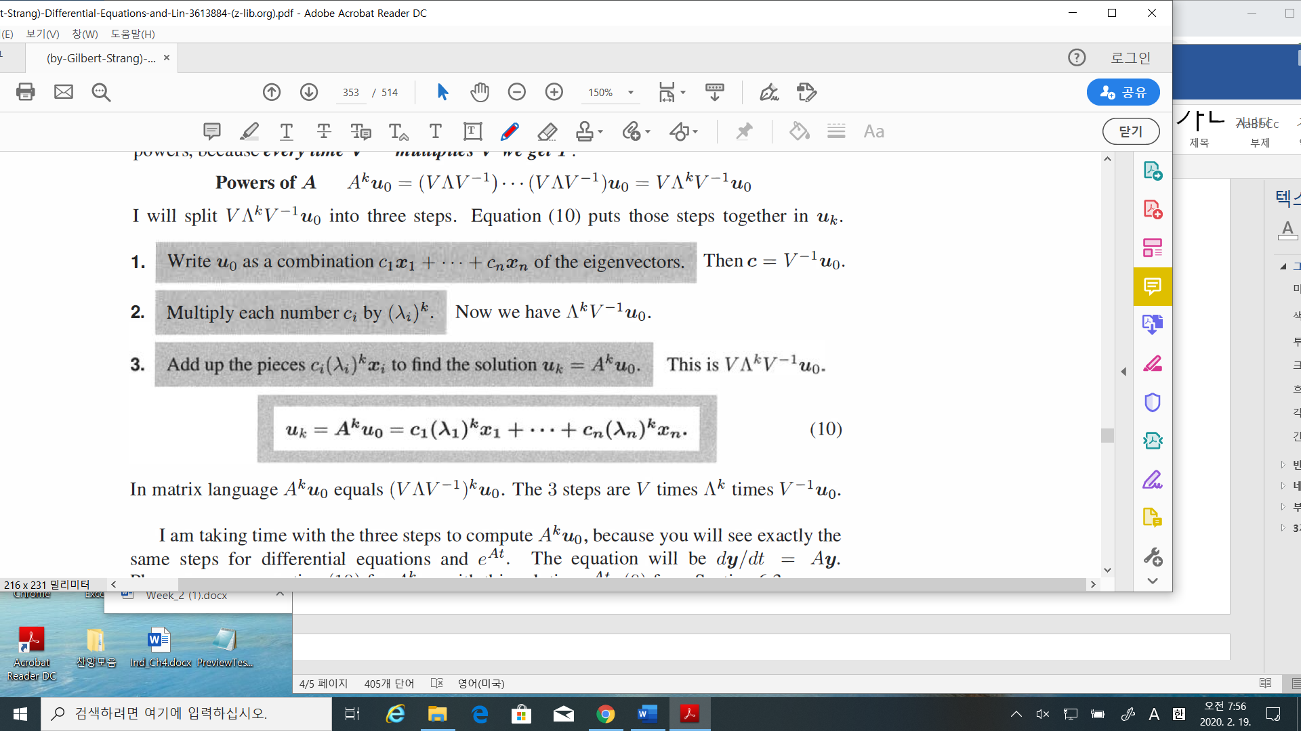

1. The solution to a differential equation

$$\frac{dy}{dt}=Ay$$

$$y\left(t\right)=e^{At}y\left(0\right)=c_{1}e^{λ_{1}t}x_{1}+ c_{2}e^{λ_{2}t}x_{2}+ ,…, + c_{n}e^{λ_{n}t}x_{n}$$

* Keep in mind.

1. $\left(λ_{1}, x_{1}\right), \left(λ_{2}, x_{2}\right),…,$ they are corresponding to each other
2. These solution are correct if $A$ is diagonalizable, i.e., “n” e-vectors are independent

* Example 3(page 342): Solution to a difference equation.

Find

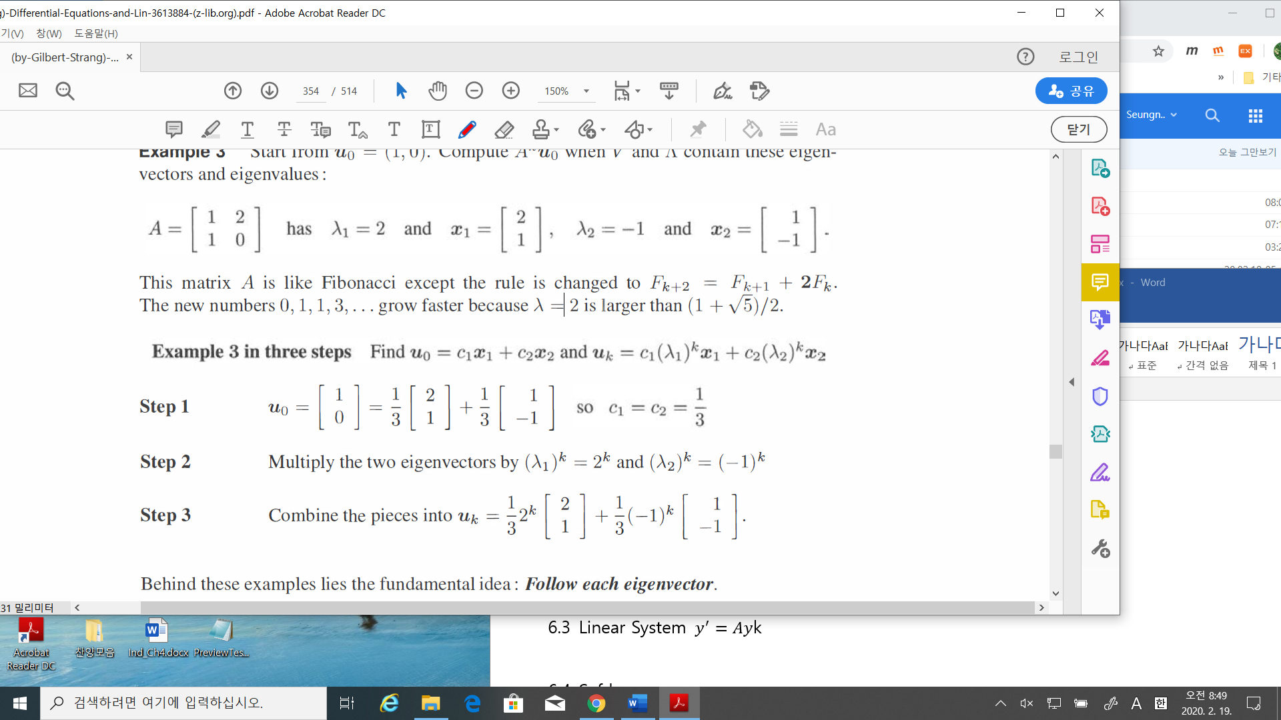



* 1. Linear System $y^{'}=Ay$
* Introduction:

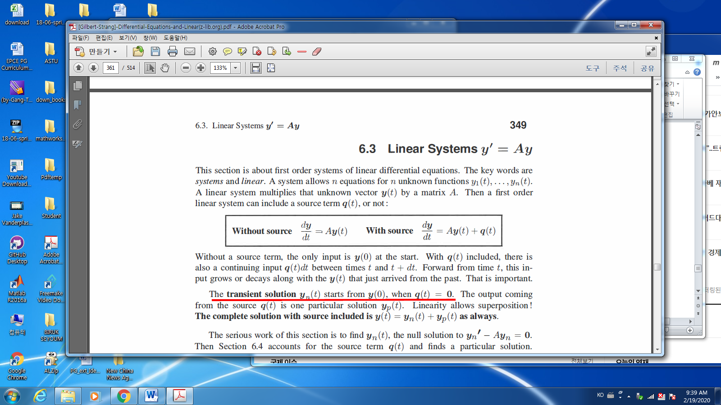

-The solution form:

$$y\left(t\right)=y_{p}\left(t\right)+y_{n}\left(t\right)$$

: The complete solution; $y\left(t\right)$

: The particular solution; $y_{p}\left(t\right)$

: The null (transient / homogeneous ) solution; $y_{n}\left(t\right)$

* Example_1: Real different e-values;

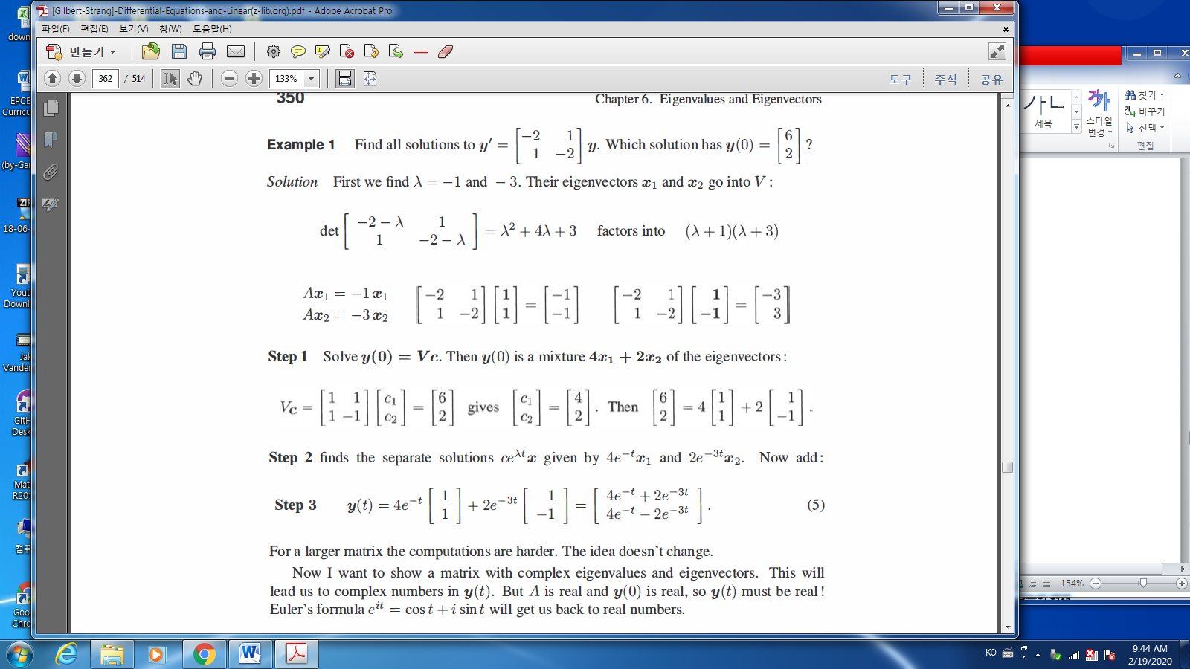

* Example_2: Complex e-values

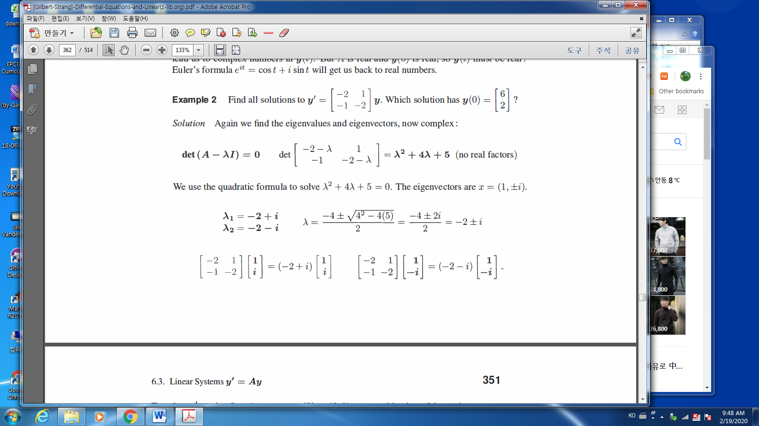

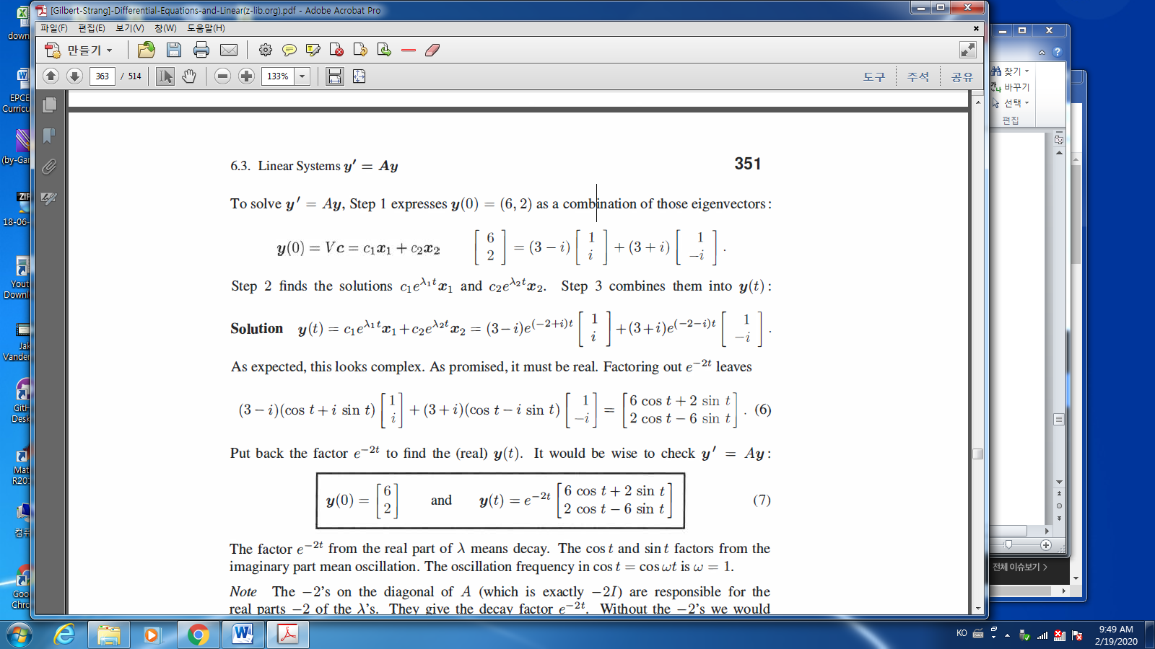

* Companion matrices:

Companion matrices: have 1’s on their super diagonal:

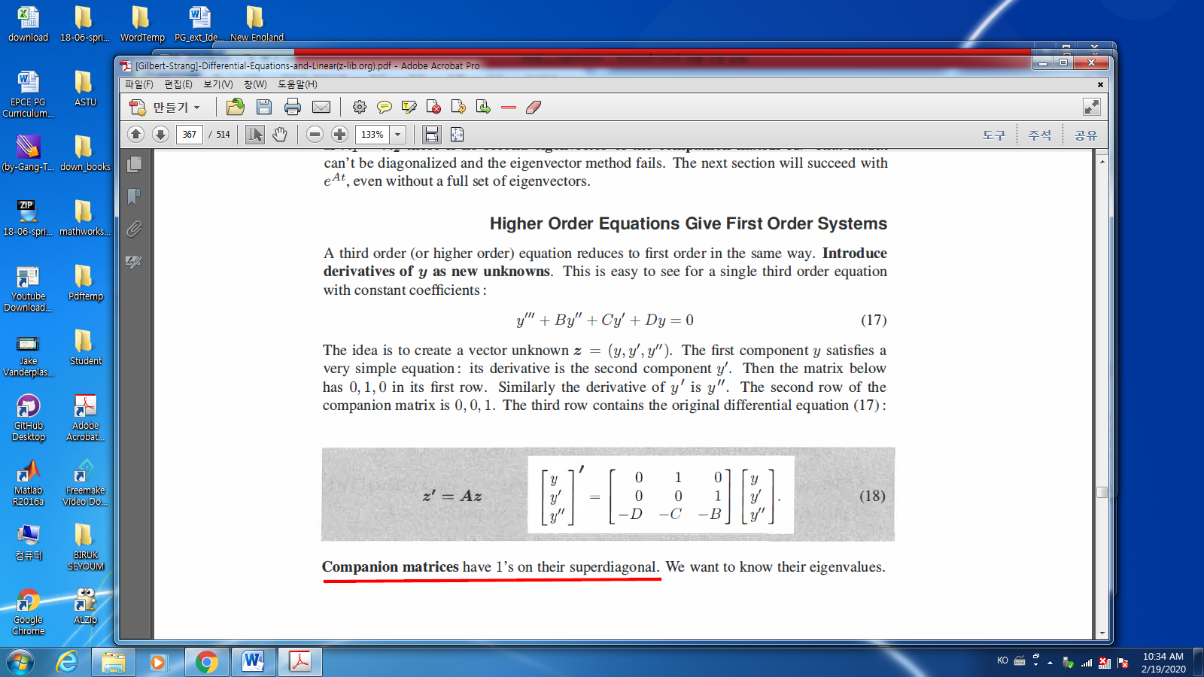

* Find e-values (Determinant of $(A-λI)$)

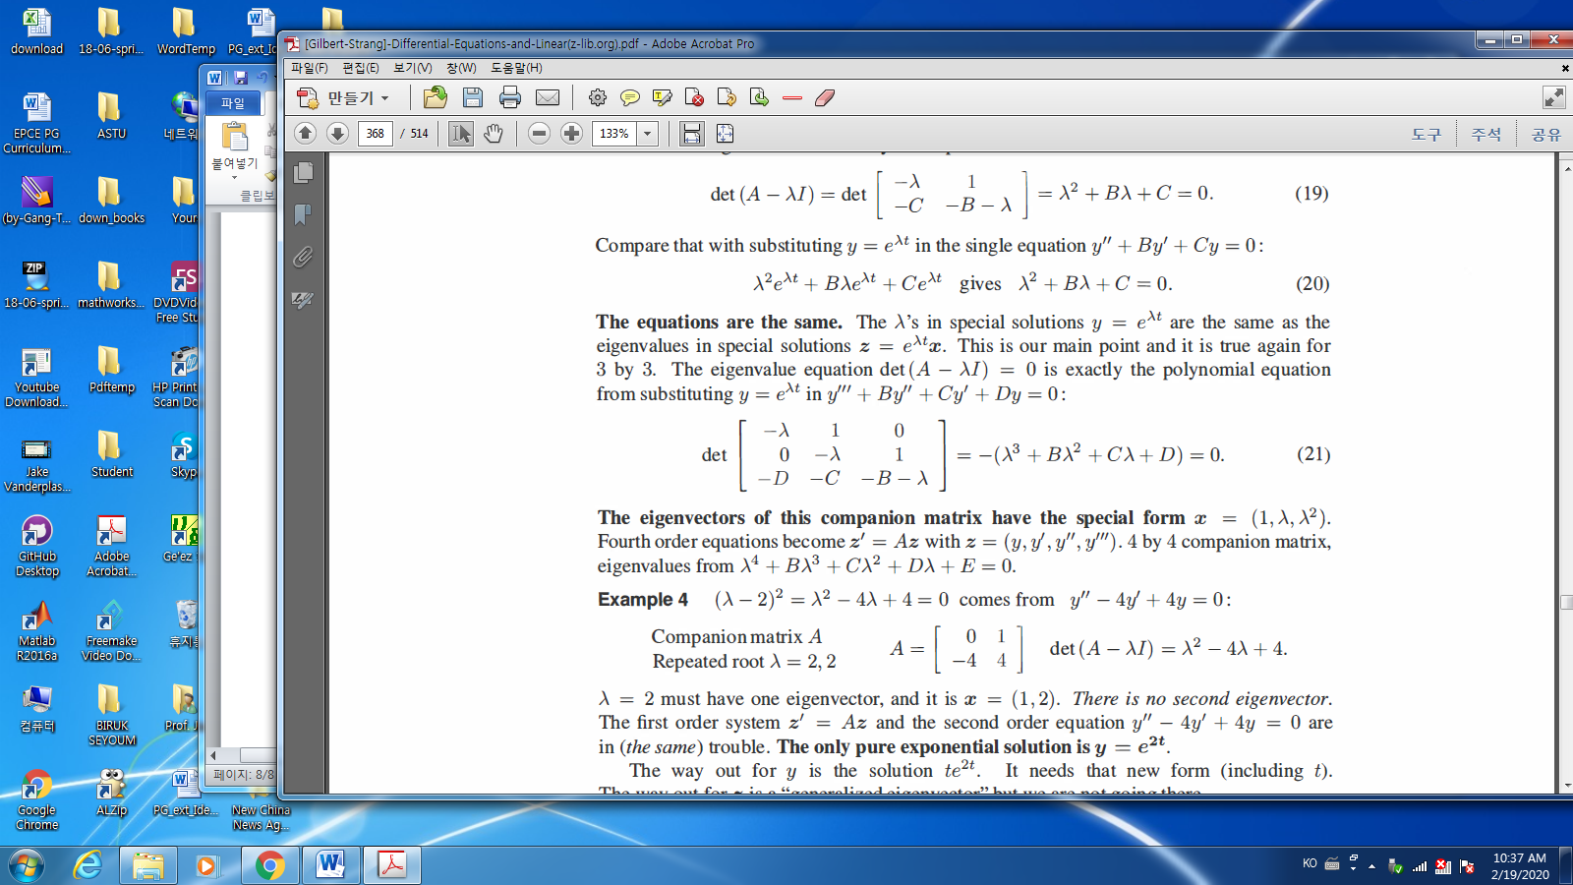

* Look the e-vectors!!

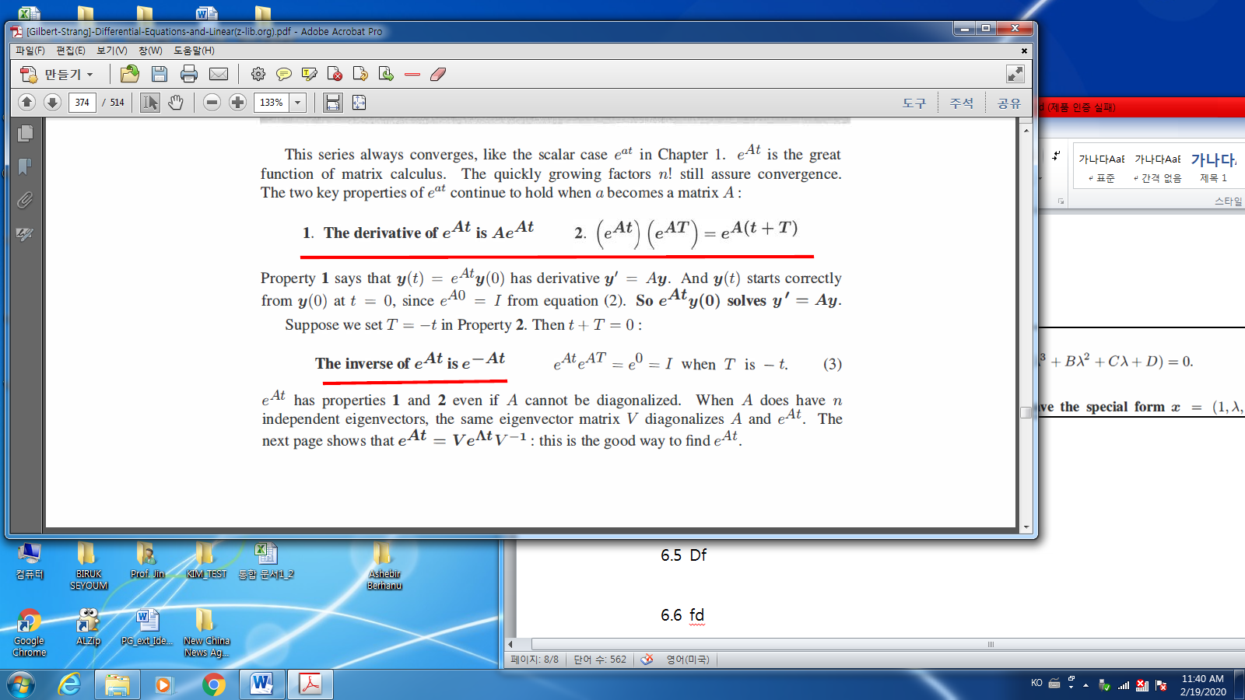

* Source term in $y^{'}=Ay+q$

1. If $q$ is constant, then

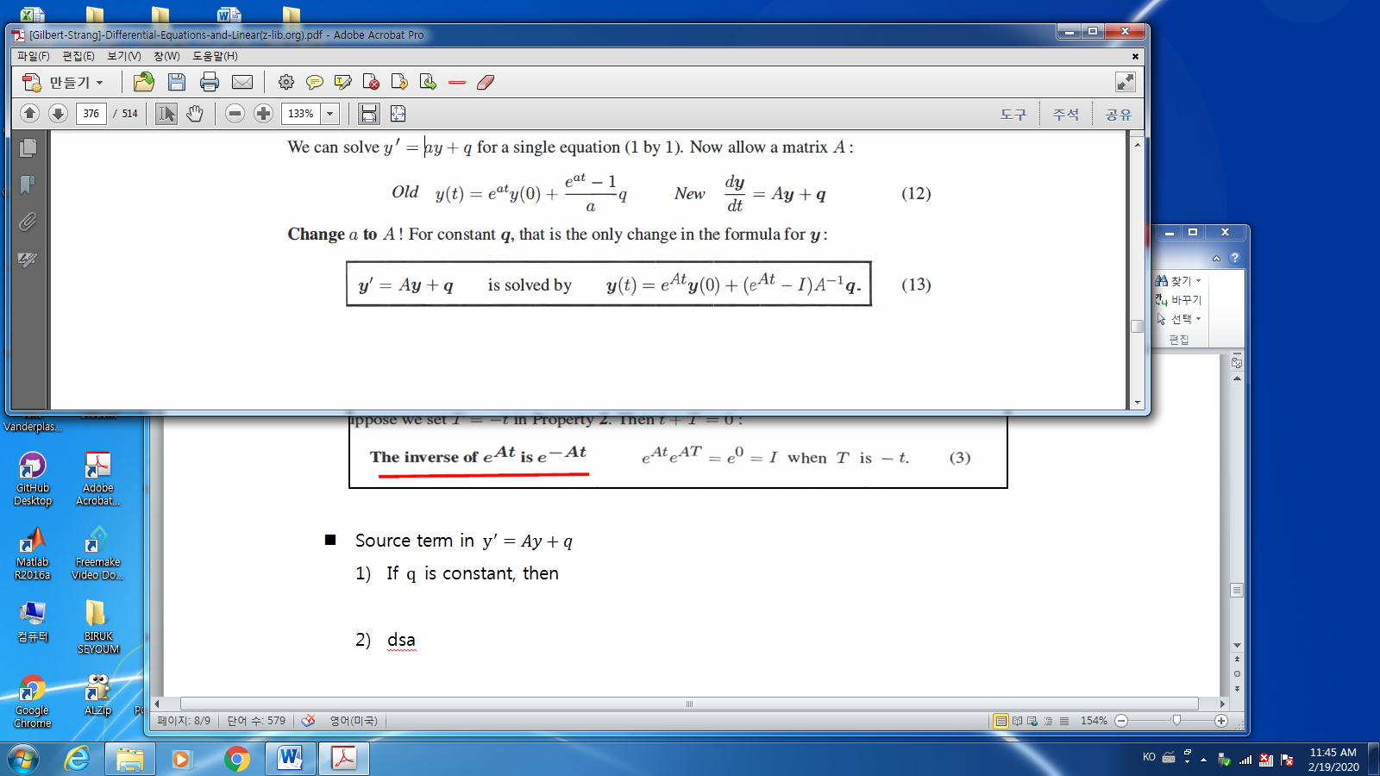

1. In general,

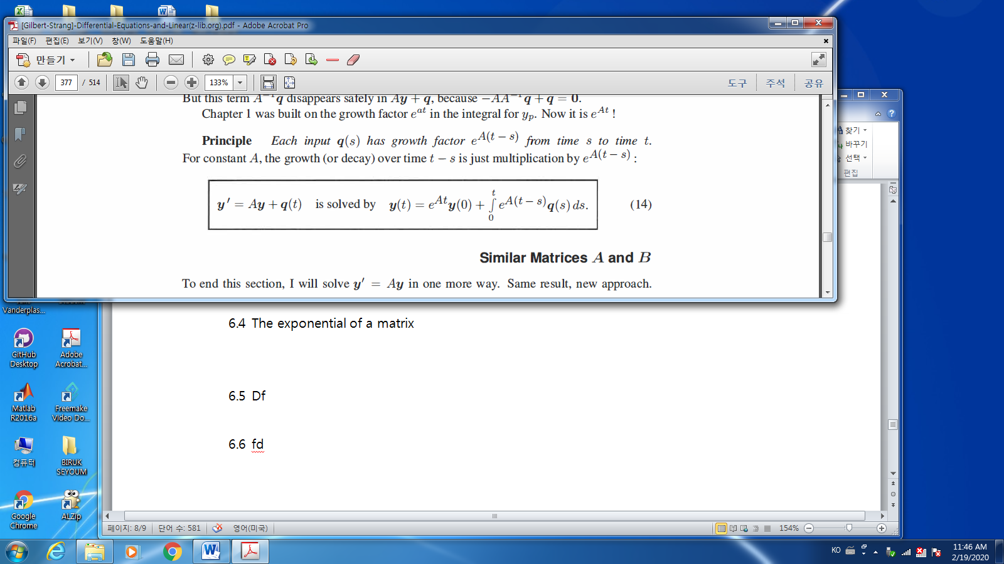

* 1. The exponential of a matrix 🡪 skip
  2. Second order systems and Symmetric matrices 🡪 skip
* Problem: find e-values/vectors of $A= \left[\begin{matrix}\cos{θ} & -\sin{θ} \\ \sin{θ} & \cos{θ}\end{matrix}\right]$
* Problem: Find e-values and e-vectors of $B,$ and C

$$B=\left[\begin{matrix}1 & 0 \\ 0 & 1\end{matrix}\right], C=\left[\begin{matrix}1 & 1 \\ 0 & 1\end{matrix}\right]$$

Problem.

Chapter. 6.1 2 / 3 / 6 / 20

Chapter. 6.3 1/ 7 /10